The Impact of War on Censorial Building Programs in the Middle Roman Republic

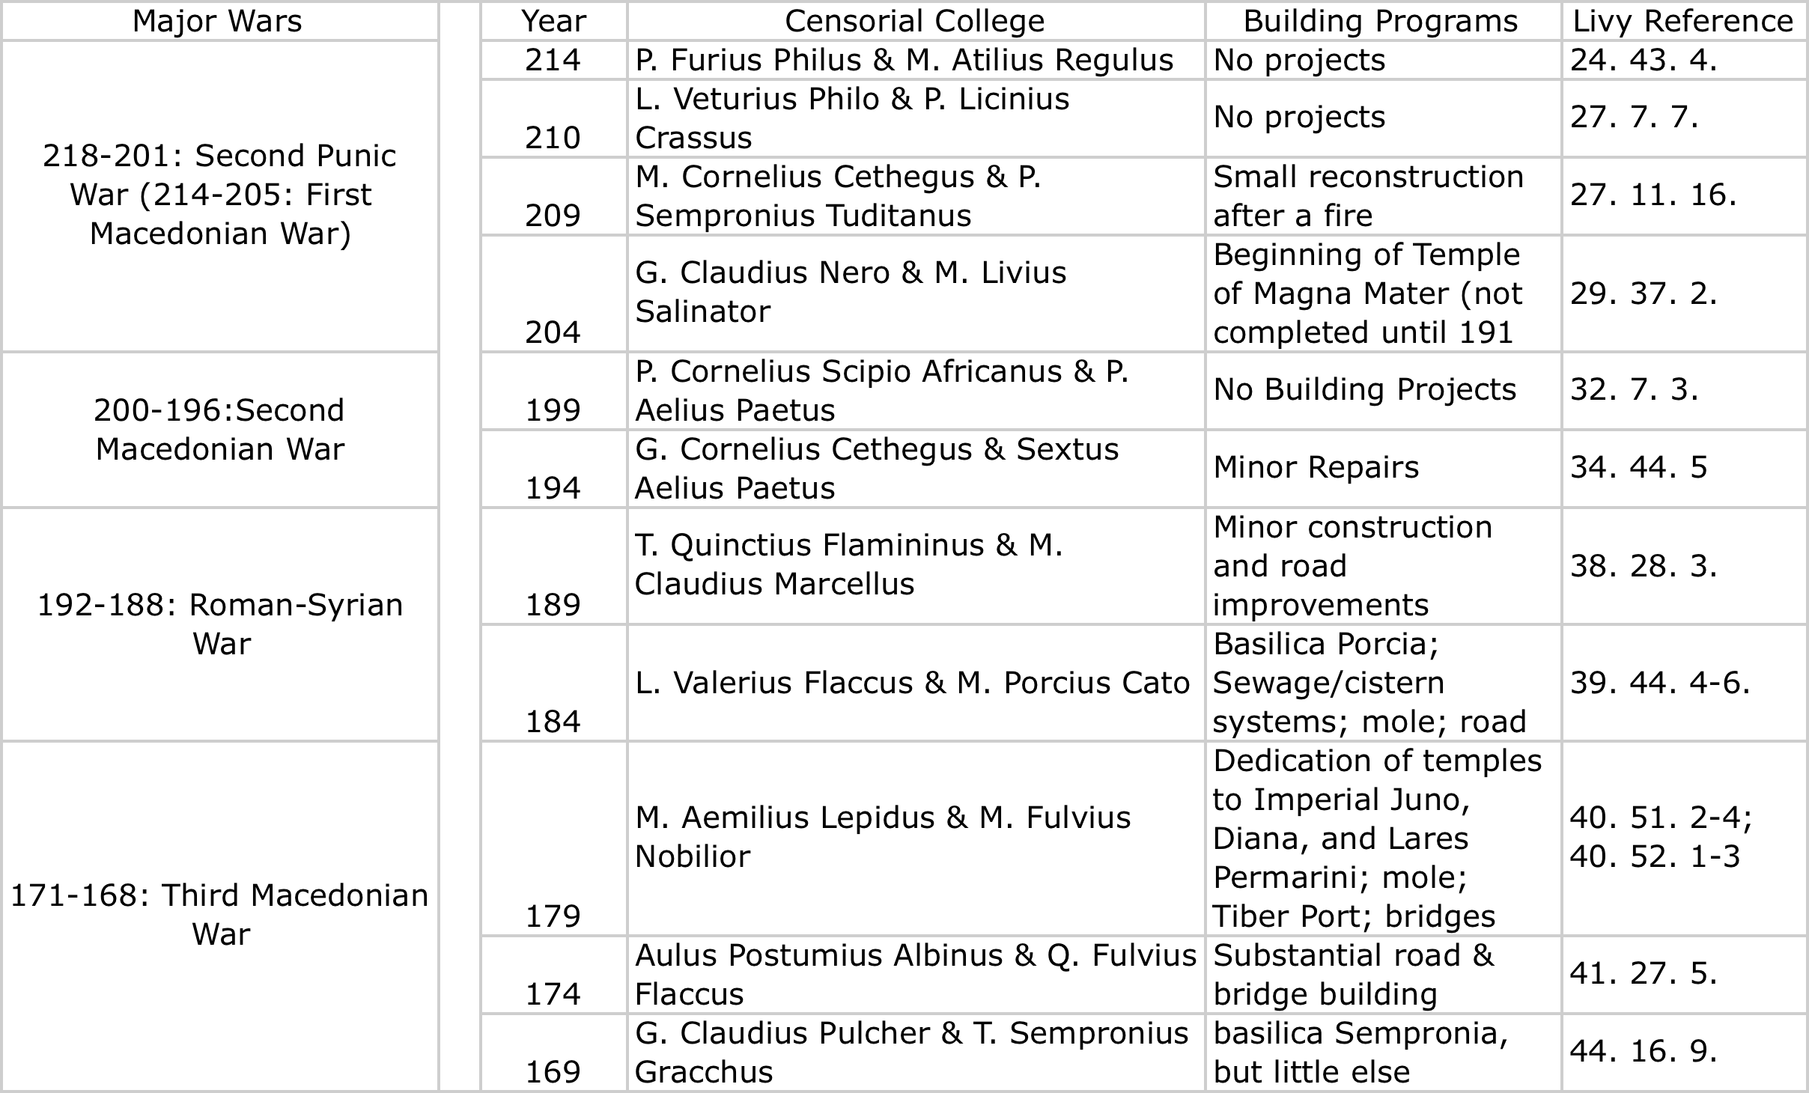

Select Bibliography
Briscoe, John. 2012. Commentary on Livy: Books 41-45. USA: Oxford University Press,
Coarelli, Fllippo. 1977. “Public Building in Rome between the Second Punic War and Sulla.” PBSR. 45: pp. 1-23
Frank, Tenney. 1927. An Economic History of Rome. Baltimore: Johns Hopkins Press
Salmon, E.T. 1970. Roman Colonization Under the Republic. Ithaca, New York: Cornell University Press
Westermann, William Linn. 1942. “Industrial Slavery in Roman Italy.” Journal of Economic History. 2 (2), pp. 149-163
Wiseman, T.P. 1970. “Roman Republican Road-Building.” PBSR. 38: pp. 122-152
Ziolkowski Adam. 1986. “The Plundering of Epirus in 167 BC: Economic Considerations.” PBSR 54: 69-80

